**Report**

Project: Explore Weather Trends

Firstly, two SQL queries were used to extract the global and local temperature data. Local data was taken for the closest city in the database. In my case local data is for Warsaw.

* SQL query for local data extraction  
  select year, city, country, avg_temp

from city_data

where city = 'Warsaw';

* SQL query for global data extraction:  
  select year, avg_temp

from global_data;

The data was extracted to .csv format and then loaded into Google Sheets, where all next steps were performed.

In local temperature data there were some missing values. Those missing values were replaced by mean for 10 years. I chose to replace it by the mean for 10 years, because later I calculate 10 year moving average.

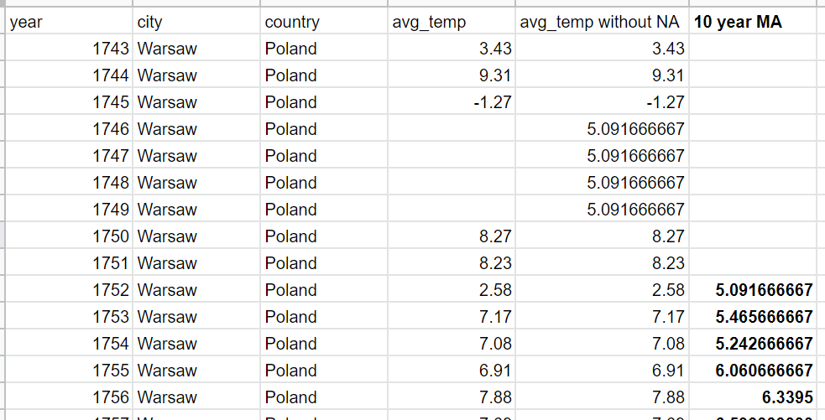

There were no missing values in global data.

Next, the 10 year moving average was calculated for both local and global data. For each 10 years in the data the average was computed, which as a results is 10 year moving average.

Example of calculating a 10 year moving average   
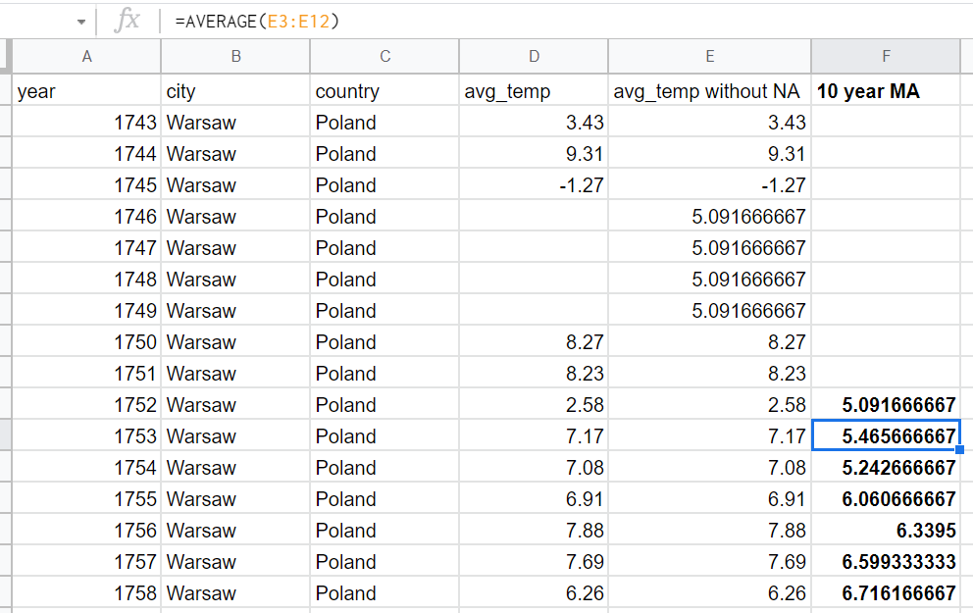

The same calculation method was used for global data.

The line chart was created and can be found below:

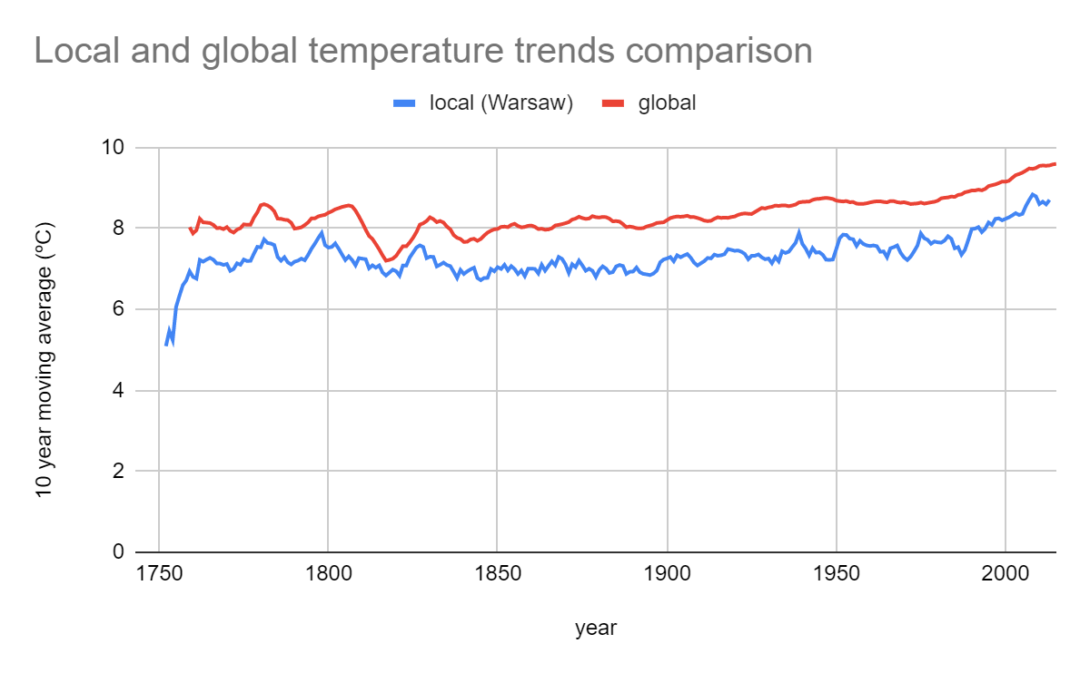

Observations:

* Overall, both local and global temperature increases in the analyzed period. The world is getting warmer.
* Local temperature is always lower than global temperature in the analyzed period.
* The difference between the global and local temperatures changed over the studied period, but there is no clear trend of those changes.
* The local temperature has greater annual fluctuations than the global temperature.
* Over the studied period, the local average temperature increased more than the global one compared to the first analyzed year (for global temperature: increase from 8.03 ºC in 1759 to 9.59 ºC in 2015 - increase by 19.5%; for local temperature: increase from 5.09 ºC in 1752 to 8.70 ºC in 2013 - increase by 71%)